FIREWALL: BENEFITS AND CHALLENGES OF NETWORK

SALISU MOHAMMED
(ST/CS/ND/20/272)

A SEMINAR REPRESENTED TO THE DEPARTMENT OF COMPUTER SCIENCE, SCHOOL OF SCIENCE AND TECHNOLOGY, FEDERAL POLYTECHNIC MUBI, ADAMAWA STATE, NIGERIA

NOVEMBER, 2022
FIREWALL: BENEFITS AND CHALLENGES OF NETWORK

SALISU MOHAMMED
(ST/CS/ND/20/272)

A SEMINAR REPRESENTED TO THE DEPARTMENT OF COMPUTER SCIENCE, SCHOOL OF SCIENCE AND TECHNOLOGY, FEDERAL POLYTECHNIC MUBI, ADAMAWA STATE, NIGERIA

IN PARTIAL FULFILLMENT OF THE REQUIREMENTS FOR THE AWARD OF NATIONAL DIPLOMA (ND) IN COMPUTER SCIENCE

NOVEMBER, 2022

Abstract

Firewalls can be an effective means of protecting a local system on network of system from network -based security threats while at the same time affording access to the outside world via wide area networks and the internet.in recent years, firewalls have become enormously popular on the internet. in large part, this is due to the fact that existing operating systems have essentially no security, and were designed under the assumption that machines and users would trust each other.

Keywords: Firewall, Network Security Issues, Benefits, Challenges

Introduction
Today's networks change and develop on a regular basis to adapt to new business situations, such as organisations, acquisitions, outsourcing, mergers, joint ventures, and strategic partnerships. Amos (2013) the increasing degree to which internal networks are connected to the Internet. The increased complexity and openness of the network thus caused makes the question of security more complicated and necessitates the development of sophisticated security technologies. The best way of ensuring interface security is the use of a firewall.
A firewall is a security tool that monitors incoming and/or outgoing network traffic to detect and block malicious data packets based on predefined rules, allowing only legitimate traffic to enter your private network. Implemented as hardware, software, or both, firewalls are typically your first line of defense against malware, viruses, and attackers trying to make it to your organization’s internal network and systems (Dowd, 2017).
Much like a walk-through metal detector door at a building’s main entrance, a physical or hardware firewall inspects each data packet before letting it in. It checks for the source and destination addresses and, based on predefined rules, determines if a data packet should pass through or not. Once a data packet is inside your organization’s intranet, a software firewall can further filter the traffic to allow or block access to specific ports and applications on a computer system, allowing better control and security from insider threats. An access control list may define specific Internet Protocol (IP) addresses that cannot be trusted. The firewall will drop any data packets coming from those IPs. Alternatively, the access control list may specify trusted-source IPs, and the firewall will only allow the traffic coming from those listed IPs. There are several techniques for setting up a firewall. The scope of security they provide also depends generally on the type of firewall and its configuration (Marianne, 2014).
A Firewall is a computer, router or other communication device that filters access to the protected network. Cheswick and Bellovin (2005), define a firewall as a collection of components or a system that is placed between two networks and possesse. the following properties:
- All traffic from inside to outside, and vice-versa, must pass through it.
- Only authorised traffic, as defined by the local security policy, is allowed to pass through it.
- The firewall itself is immune to penetration.
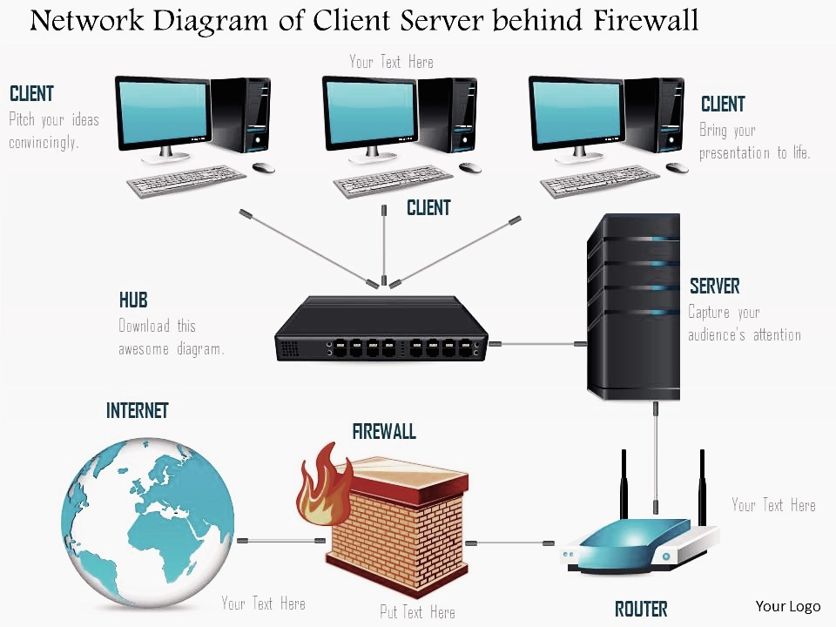
Figure: Firewall Schematics (Amos, 2013).
Design goals for a firewall
- The first design goal for fire wall is that collectively the sum of all the
- network traffic from internal to external must go through the firewall physically
- Cutting off all access to the local network except via the firewall.
- The second design goal would be only authorized traffic which is
- delineated by the local security policy will be allowed to proceed.
- Finally, the last design goal is that the firewall itself is resistance to penetration
- inclusive is a solid trustworthy system with a protected
- operating system.
History of firewall
According to Avinashi (2011), the first firewalls were developed in the 1980s at the American technology companies Cisco Systems and Digital Equipment Corporation. These “network layer” firewalls judged packets based on simple information such as their apparent source, destination, and connection type. Although fast and transparent, these systems were fairly easily foiled. In the early 1990s a new generation of “application layer” firewalls emerged; though more cumbersome to set up and operate, they performed a more thorough inspection. In the early 21st century, most firewalls were hybrids of these two primary types.
Advantages of firewall
- Traffic Monitoring
- Protection against Virus.
- Security from Hackers.
- Easy Installation.
- Protection against Malware.
Traffic monitoring.
The main advantage of using a firewall is that it can measure and monitor entire traffic passing through it.
The information or data passing through or within the network is in the form of packets.
A firewall helps itself in diagnosing and checking if there is any dangerous program or code attached to the packet.
If the firewall comes to know that the packets are infected and contaminated with malicious programs it blocks further access to the packets.
Protection against Virus.
The firewall is designed and developed in such a way that they act as a protective wall and shield between our computer system and these unwanted programs.
They have a security feature that is activated when they come in contact with such unauthorized files and programs.
The programs or software’s through which this virus wants to infect other computers in the network are blocked and eliminated by the firewall.
Security from Hackers.
The hardware routers are more capable of handling hackers and spammers because of their silent feature.
They also enhance the security of the packet filtering firewall. Therefore, they provide ultimate protection from hackers.
Easy Installation.
The installation process of a software firewall is quite simple and can be done without any professional guidance.
Moreover, there are some tutorials available on the internet which helps in learning the complete process in detail.
Modern Operating systems like Windows 7, Windows 8, Windows 10 come with pre-installed firewalls.
however, the hardware firewall is difficult to install and maintain to access them we need to take professional advice.
Protection against Malware.
Some malware can reside in the computer system unknowingly and can replicate itself multiple times.
This malware can collect all the important data and information from your system and later misuse them in the form of personal as well as financial loss.
This malware is smart enough and can not be identified easily therefore a proper firewall must be installed to require a fair amount of security from such malware like a trojan horse.
Trojan Horses is a malicious program designed, developed, planned, and created to harm the computer system.
The codes are customized such that when it interacts with some other program or documents it changes them into the Trojan virus.
Disadvantages of firewall
- Cost
- Performance
- Malware Attacks
- Maintenance
- Internal Network Attacks
- Firewall Removal
Cost
No doubt the software firewall is cheaper and comes with the latest and updated operating systems like Windows 7, Windows 8, Windows 10, and Windows 10.2.
Some of the software firewalls also come with premium antivirus software. However, the hardware firewall is considered to be a little expensive when compared to other
firewalls but it also offers a great deal of protects from hackers and malware. For the installation of this hardware firewall, professional guidance and help is needed.
Performance
It has been observed that the software firewall restricts the performance of the computer system.
They tend to use the system resources and memory resources from RAM [Random Access Memory] that does not allow the system to run with full potential.
The heavy usage of memory reflects in slow speed and lagging of system if found this is because the firewall continuously runs in the background unknowingly.
Malware Attacks
The software, as well as hardware-based firewall, are vulnerable despite its continuous development.
The firewall is updated periodically to enhance the database of the virus definition still in the majority of the cases it has been observed that they let some of the malware undetected.
Therefore, heavy rely on the software or hardware-based firewall is not advised.
Maintenance
The software or hardware-based firewall is a very difficult task to maintain as we have to
periodically check the new policies and apply them to the system whereas the old policies and to be taken into consideration.
Internal Network Attacks
They are very difficult and tedious to identify as the culprit has internal access to the system.
Therefore, the firewalls are not capable of detecting such sources which have the authorized credentials to access the system
The firewalls are designed and developed to stop attacks from outside the network and other sources and hence they are incapable of handling such incidents which occur inside the networks.
Firewall Removal
While software-based firewalls are installed some of the important files incorporate with the operating systems kernel and dll files and hence when we try to remove these firewalls they refuse to remove them completely from the system.
Software and hardware firewalls
Structurally, firewalls can be software, hardware, or a combination of both.
Software Firewalls
Software firewalls are installed separately on individual devices. They provide more granular control to allow access to one application or feature while blocking others. But they can be expensive in terms of resources since they utilize the CPU and RAM of the devices they are installed on, and administrators must configure and manage them individually for each device. Additionally, all devices within an intranet may not be compatible with a single software firewall, and several different firewalls may be required (John & Amos, 2014).
Hardware Firewalls
John and Amos (2014), On the other hand, hardware firewalls are physical devices, each with its computing resources. They act as gateways between internal networks and the internet, keeping data packets and traffic requests from untrusted sources outside the private network. Physical firewalls are convenient for organizations with many devices on the same network. While they block malicious traffic well before it reaches any endpoints, they do not provide security against insider attacks. Therefore, a combination of software and hardware firewalls can provide optimal protection to your organization’s network.
Types of firewalls
According to Charles (2007), Firewalls are also categorized based on how they operate, and each type can be set up either as software or a physical device. Based on their method of operation, there are four different types of firewalls.
Packet Filtering Firewalls
Packet filtering firewalls are the oldest, most basic type of firewalls. Operating at the network layer, they check a data packet for its source IP and destination IP, the protocol, source port, and destination port against predefined rules to determine whether to pass or discard the packet. Packet filtering firewalls are essentially stateless, monitoring each packet independently without any track of the established connection or the packets that have passed through that connection previously. This makes these firewalls very limited in their capacity to protect against advanced threats and attacks (Charles, 2007).
Packet filtering firewalls are fast, cheap, and effective. But the security they provide is very basic. Since these firewalls cannot examine the content of the data packets, they are incapable of protecting against malicious data packets coming from trusted source IPs. Being stateless, they are also vulnerable to source routing attacks and tiny fragment attacks. But despite their minimal functionality, packet filtering firewalls paved the way for modern firewalls that offer stronger and deeper security.
Circuit-Level Gateways
Working at the session layer, circuit-level gateways verify established Transmission Control Protocol (TCP) connections and keep track of the active sessions. They are quite similar to packet filtering firewalls in that they perform a single check and utilize minimal resources. However, they function at a higher layer of the Open Systems Interconnection (OSI) model. Primarily, they determine the security of an established connection. When an internal device initiates a connection with a remote host, circuit-level gateways establish a virtual connection on behalf of the internal device to keep the identity and IP address of the internal user hidden (Charles, 2007).
Circuit-level gateways are cost-efficient, simplistic, barely impact a network’s performance. However, their inability to inspect the content of data packets makes them an incomplete security solution on their own. A data packet containing malware can bypass a circuit-level gateway easily if it has a legitimate TCP handshake. That is why another type of firewall is often configured on top of circuit-level gateways for added protection.
Stateful Inspection Firewalls
A step ahead of circuit-level gateways, stateful inspection firewalls, and verifying and keeping track of established connections also perform packet inspection to provide better, more comprehensive security. They work by creating a state table with source IP, destination IP, source port, and destination port once a connection is established. They create their own rules dynamically to allow expected incoming network traffic instead of relying on a hardcoded set of rules based on this information. They conveniently drop data packets that do not belong to a verified active connection.
Stateful inspection firewalls check for legitimate connections and source and destination IPs to determine which data packets can pass through. Although these extra checks provide advanced security, they consume a lot of system resources and can slow down traffic considerably. Hence, they are prone to DDoS (distributed denial-of-service attacks) (Charles, 2007).
Application-Level Gateways (Proxy Firewalls)
Application-level gateways, also known as proxy firewalls, are implemented at the application layer via a proxy device. Instead of an outsider accessing your internal network directly, the connection is established through the proxy firewall. The external client sends a request to the proxy firewall. After verifying the authenticity of the request, the proxy firewall forwards it to one of the internal devices or servers on the client’s behalf. Alternatively, an internal device may request access to a webpage, and the proxy device will forward the request while hiding the identity and location of the internal devices and network.
Unlike packet filtering firewalls, proxy firewalls perform stateful and deep packet inspection to analyze the context and content of data packets against a set of user-defined rules. Based on the outcome, they either permit or discard a packet. They protect the identity and location of your sensitive resources by preventing a direct connection between internal systems and external networks. However, configuring them to achieve optimal network protection can be tricky. You must also keep in mind the tradeoff—a proxy firewall is essentially an extra barrier between the host and the client, causing considerable slowdowns (Charles, 2007).
A firewall is an essential part of your cybersecurity. It serves an integral part in your organization’s defense against threats and cyber attacks.
The role of firewalls in depending your data
A firewall protects many vulnerable programs on your systems. It forms one of the crucial layers in a company’s layered security strategy. If you want a layered security architecture, you need a stable firewall.
Besides the firewall, your layered security should also include the following;
- Regular assessments
- Endpoint protection
- Employee training and awareness
- Web and email filtering
- User access control
- Patch management
- Data backups.
Conclusion
One of the best things about a firewall from a security standpoint is that, it stops anyone on the outside from logging onto a computer in your private network
While this is a deal for business, most home networks will probably not be threatened in this manner. Still, putting a firewall in place provide some peace of mind.
Recommendations
Hackers are advancing in their wicked research to bring more harmful security threat to computer user's, firewall research has far go beyond them to handle such threat as the come.
I therefore recommend installation of firewall to system user's be it standalone, home network or an office network, this in turn reduce the security risk.

REFERENCES
Avinashi, A. (2011). Firewalls are the first line of defence in protecting against unauthorized access. IEEE Internet of Things Journal, 5(1), 45-19.
Charles, I. (2007). Understanding the benefits of firewall security is the first step needed. Network Security Journal of US, 8(7), 23-45.
Cheswick, A. & Bellovin, E. (2005). Firewall as a collection of components or a system that is placed between two networks and possessed. the following properties: Journal of IBM Service Management, 4(5), 31-39.
Dowd, M. (2017). Firewalls outside as the configuration rules is given in the firewalls by administrators. IEEE Journal of Symposium on Security and Privacy, 2(7), 67-78.
John, T. & Amos, M. (2014). A Hardware Firewall is a device that typically sits between your devices and the internet that filters out network traffic. Journal of ACM Transactions on firewalls Networks, 6(4), 34-67.
Marianne, I. (2014). Proxy Server is like a sharing (Virtual) machine. Journal of Harrington Network Security, 4(4), 9-15.

